

Copyright Transfer Agreement

Manuscript Title: Iatrogenic Glans Penis Injury During Circumcision: Clinical Spectrum, Mechanisms, and Medicolegal Implications—A Systematic Review

The Author and each co-authors agree to sign copyright transfer agreement form and own the full responsibility. The copyright of the article is therefore transferred to Translational Research in Urology. However, the authors retain the following rights.

- All rights suspended out of the scope of copyright; i.e. patent.
- Author’s right to use the entire or a part of the manuscript in his/her future research such as books and academic lectures except publication in scientific journals.
- Rights to reprint the article for personal use provided that the reprints are not sold.

PLEASE NOTE: The accepted manuscript cannot be processed for publication until the publisher has received this signed form. The form MUST be signed by the Corresponding Author and then scanned and sent through the system or email. If the manuscript is not published in the Journal, this release will not take effect.
The sole responsibility for the whole content (s) of the article remains only with the corresponding author. However, Editor would reserve the right to adjust the style to certain standards of uniformity before publication.

Abdul Hakim Nitiprodjo Signature: ____________________

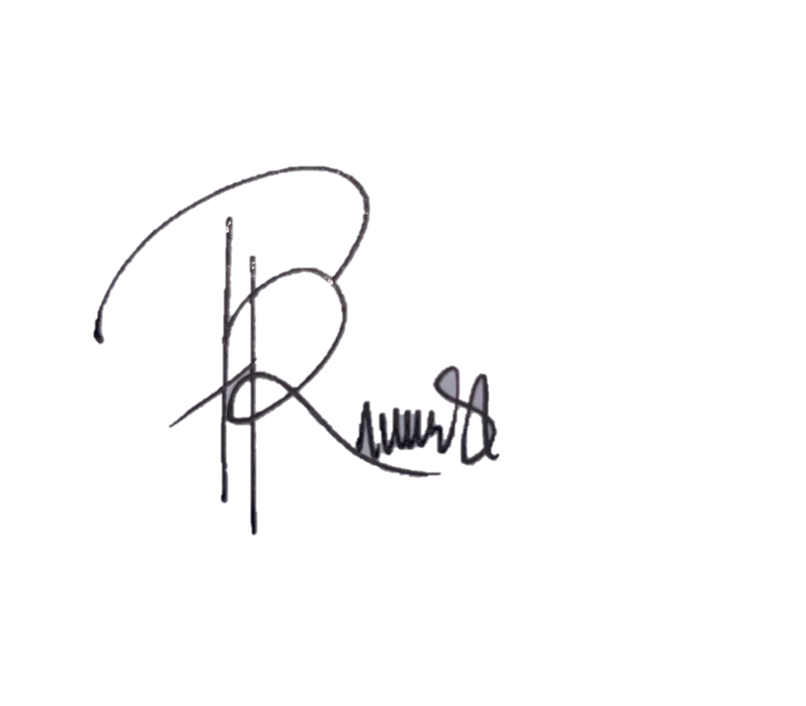Andi Muhammad Maulana Signature: ____________________

Prima Maharani Putri Signature: ____________________

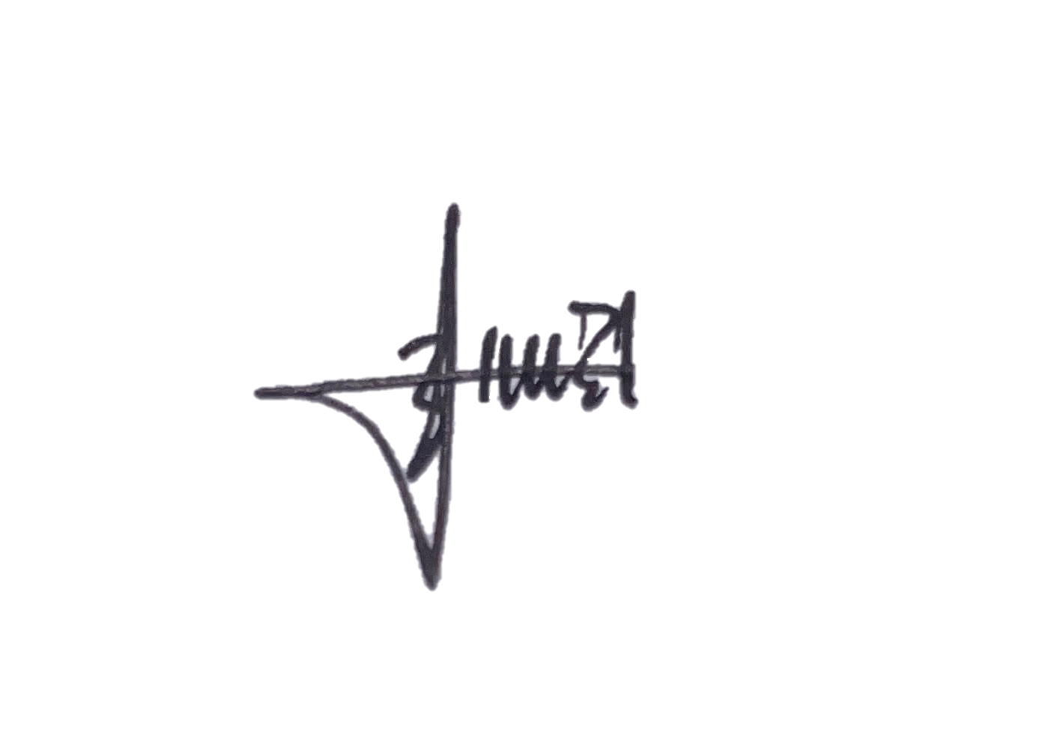Titik Kusumawinakhyu Signature: ____________________

Tegar Fitriyana S. Karso Signature: ____________________

Date: 08 September 2026

